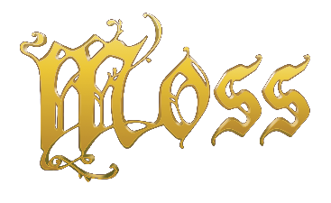

Moss Announced as a Launch Title for Oculus Quest VR Headset at Oculus Connect 5

SAN JOSE, CA – September 26, 2018 – Moss, the acclaimed action-adventure puzzle game for VR, took center stage today at Oculus Connect 5 when Mark Zuckerberg, Chief Executive Officer of Facebook, revealed Moss as a launch title for the Oculus Quest during his keynote presentation. Revered as one of the best VR titles to date because of its intuitive gameplay, creative design, and high degree of artistic polish, Moss brings a unique experience to gamers around the world. And now, with the untethered technology coming in the Quest, players will have the freedom to explore and share the world of Moss whenever and wherever they want when the headset is released in Spring 2019.

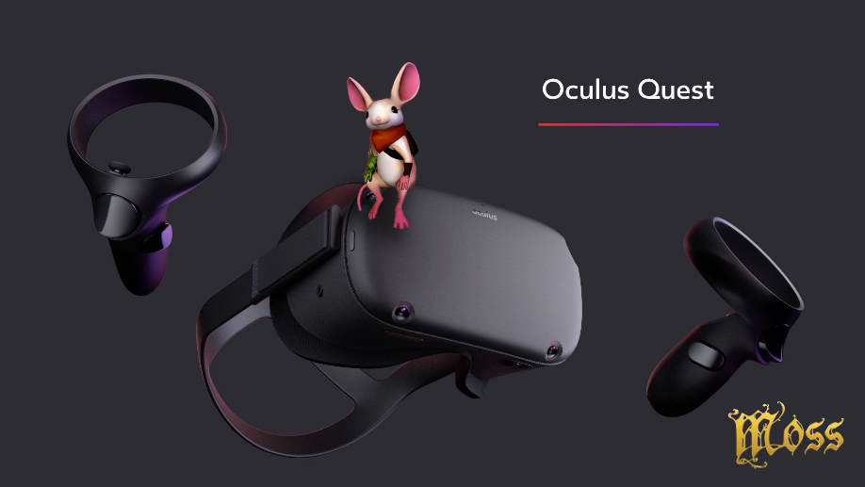

In Moss, players guide a young mouse hero named Quill on an epic journey while also manipulating the field of play as their own character and key ally to Quill. Crafted to maximize the transformative magic of VR, Moss allows players to reach into a dynamic world—their every action having impact. Since Moss launched earlier this year on PlayStation VR, Oculus Rift, and HTC Vive, it has retained a top rating across numerous charts and been nominated for multiple “VR Game of the Year” awards.

It was also announced during Oculus Connect 5 that come this October 2018, current Oculus Rift owners will be able to unlock two unique Moss items to decorate their virtual Oculus Home. Unlock a virtual poster by artist Ryan DeMita by ascending to the castle, and unlock a virtual Quill figurine by giving her a high five in-game.
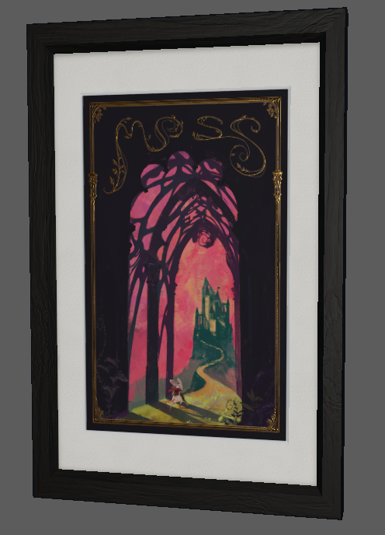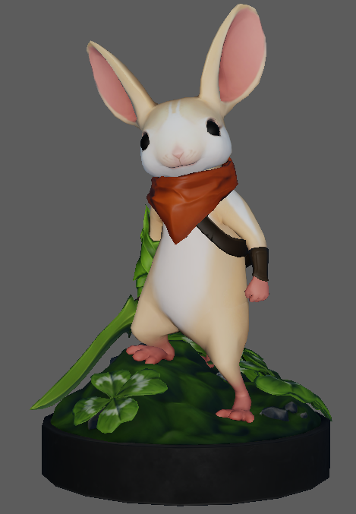

Players attending Oculus Connect 5 this week can explore Moss on the Oculus Rift via a playable demo on Wednesday, October 26 from 3:30-7pm and Thursday, October 27 from 11:30-2:15pm.

Moss, the highest-rated MetaCritic PSVR title released in more than a year, is currently available at PlayStation Store, Steam, Oculus Rift, and HTC Viveport for 29.99 USD MSRP.

Moss is rated E10+ by the ESRB. For more information, visit www.polyarcgames.com and follow the official Polyarc channels Facebook, Twitter, YouTube, and Instagram.

© 2018 Polyarc, Inc. All rights reserved. Moss is a trademark of Polyarc, Inc.

About Polyarc
Polyarc, located in Seattle, was founded in 2015 to explore the energizing and momentous possibilities of virtual reality, and to champion a culture where deep collaboration, creative expression, and high player value are at the forefront of every innovation. Polyarc’s team is made up of talented developers with deep experience working on well-known, AAA franchises such as Destiny, Halo 3: ODST, Halo: Reach, Red Dead Redemption, and Guild Wars 2. https://www.polyarcgames.com/

# # #

