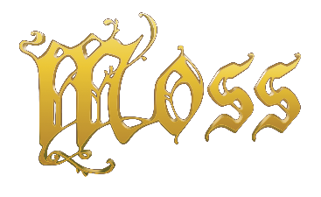

Moss™ Now Available for Pre-Order Today – Set for Release February 2018 on PlayStation®VR

Details Announced During PlayStation’s Paris Games Week Livestream: Fans Can Now Pre-Order Moss and Instantly Receive Exclusive Pre-Order Bonuses

PARIS, FRANCE – October 30, 2017 – Gamers looking to experience the full potential of PlayStation VR are one step closer today as Polyarc kicks off pre-orders for Moss, the breakthrough action-adventure puzzle game revealed earlier this year during Sony’s 2017 E3 Press Conference. Slated for release in February 2018, fans in North South and Latin America, Europe, the United Kingdom, and Australia can now pre-order Moss at PlayStation Store for $29.99 USD MSRP.

Since its debut, Moss has captured fans’ imaginations with intuitive virtual reality gameplay, creative design, and a high degree of artistic polish. With notable industry accolades and more than 20 global awards and nominations—including a Game Critics E3 2017 nomination for “Best VR Game”—Moss is one of the most anticipated gaming experiences coming to PlayStation VR.

Celebrating today’s announcement, Polyarc is rewarding fans who pre-order with instant access to an exclusive dynamic PlayStation Theme and PlayStation Avatar featuring Moss’s hero Quill and her idyllic forest home. European fans pre-ordering Moss will receive their pre-order bonuses at launch this February. Preview the dynamic theme and avatar on Polyarc’s social channels.

Moss is rated E for Everyone by the ESRB. For more information on Moss, visit www.polyarcgames.com and follow the official Polyarc channels on Facebook, Twitter, YouTube, and Instagram.

© 2017 Polyarc, Inc. All rights reserved. Moss is a trademark of Polyarc, Inc.

About Moss
Moss is a single-player action-adventure puzzle game and new IP tailor-made for the VR platform. It takes classic components of a great game—such as compelling characters, gripping combat, and captivating world exploration—and combines them with the exciting opportunities of virtual reality. Throughout gameplay, players build an extraordinary alliance with Quill, Moss’s brave new hero. Players not only guide Quill on her journey, but also reach into the world as their own character—their every action has impact.

About Polyarc
Polyarc, located in Seattle, was founded in 2015 to explore the energizing and momentous possibilities of virtual reality, and to champion a culture where deep collaboration, creative expression, and high player value are at the forefront of every innovation. Polyarc’s team is made up of talented developers with deep experience working on well-known AAA franchises such as Destiny, Halo 3: ODST, Halo: Reach, Red Dead Redemption, and Guild Wars 2. https://www.polyarcgames.com/

# # #

